***Load Balancer Lab***

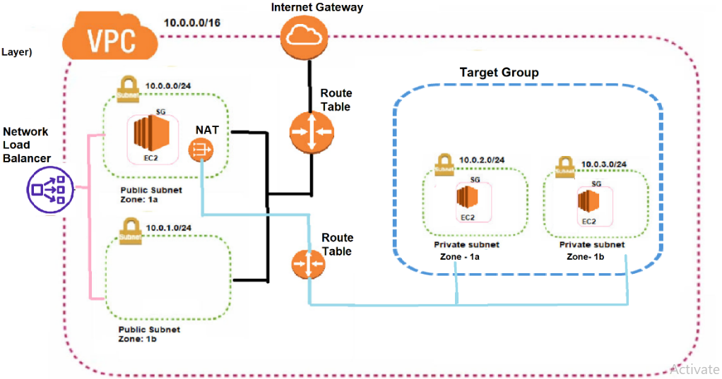

### **High-level steps**

1. Create a **VPC**.
2. Create an **Internet Gateway** and attach it to the VPC.
3. Create **4 Subnets**

two public subnets: one in Availability Zone 1a and another in 1b.

two private subnets:one in Availability Zone 1a and another in 1b.

1. Create  **route table 1**

Associate the Internet Gateway to both public subnets in Availability Zones 1a and 1b.

1. Create a **security group** with inbound rules for SSH and HTTP access.
2. Launch Three **EC2 instances**

one EC2 instance in the public subnet in AZ 1a,

one EC2 instance in the private subnet in AZ 1a

one EC2 private subnet in AZ 1b

1. Create a **NAT Gateway** in the public subnet in AZ 1a.
2. Create  **route table 2**

Associate the NAT Gateway to both Private subnets in Availability Zones 1a and 1b.

1. **Bastion Host :**

Access instance created on private subnet through instance created on public subnet.

*Linux Commands:*

1. *vi gudachari.pem*
2. *press i*
3. *add key*
4. *Esc*
5. *:wq!*
6. Install ***Apache webserver*** on **private server 1** using below commands
7. *sudo su -*
8. *sudo yum install httpd -y*
9. *sudo systemctl start httpd*
10. *sudo systemctl enable httpd*
11. *cd /var/www/html*
12. *vi index.html*
13. *press i*
14. *add blow html code*

*<h1>Welcome to Private Server 1</h1>*

1. *ESC then :wq!*
2. *Hit enter*

*Note : Linex command to o back : Ctrl+D*

1. Install **Apache webserver** on **private server 2** using below commands
2. *sudo su -*
3. *sudo yum install httpd -y*
4. *sudo systemctl start httpd*
5. *sudo systemctl enable httpd*
6. *cd /var/www/html*
7. *vi index.html*
8. *press i*
9. *add blow html code*

*<h1>Welcome to Private Server 2</h1>*

1. *ESC then :wq!*
2. *Hit enter*
3. Create a **target group** and add the private instance in AZ 1a and in AZ 1b.
4. Set up a **Network Load Balancer** with Availability Zones 1a and 1b public subnets.
5. Copy the **DNS name** of the Load Balancer and open it in an internet browser.
6. If all configurations are correct, the index home page should be displayed as

*Welcome to Private Server 1*

*after Refresh*

*Welcome to Private Server 2*

*after Refresh*

*Welcome to Private Server 1*

*after Refresh*

*Welcome to Private Server 2*